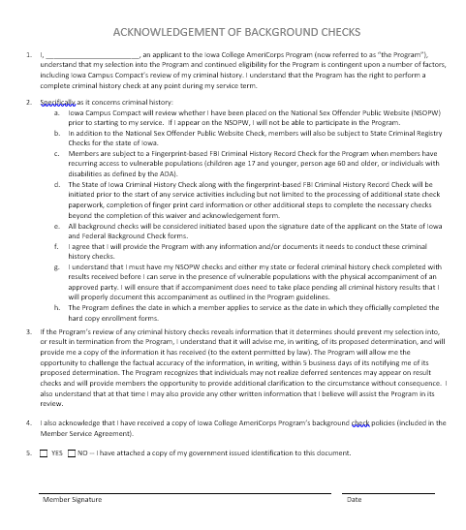 | Acknowledgement of Background Checks  Instructions  - Read the entire document  - Sign and date  - Retain a copy for your records
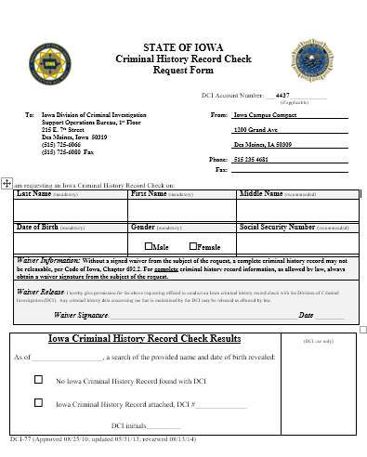 | State of Iowa Background Check Form  Instructions  - Read the waiver section  - Enter your personal information (including Social Security Number)  - Sign and date
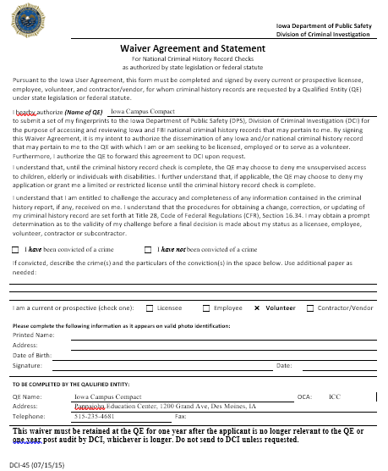 | FBI Waiver  Instructions  - Read the waiver section  - Enter your personal information  - Sign and date
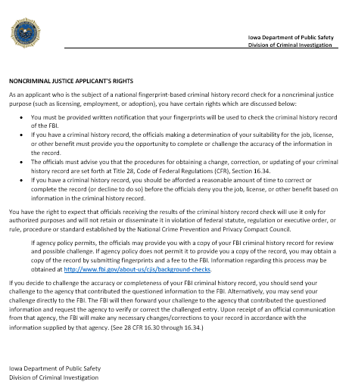 | Applicant Rights  Instructions  - Read the entire document  - Retain the original document for your records

- I, ________________________, an applicant to the Iowa College AmeriCorps Program (now referred to as “the Program”), understand that my selection into the Program and continued eligibility for the Program is contingent upon a number of factors, including Iowa Campus Compact’s review of my criminal history. I understand that the Program has the right to perform a complete criminal history check at any point during my service term.
- Specifically as it concerns criminal history:
  - Iowa Campus Compact will review whether I have been placed on the National Sex Offender Public Website (NSOPW) prior to starting to my service. If I appear on the NSOPW, I will not be able to participate in the Program.
  - In addition to the National Sex Offender Public Website Check, members will also be subject to State Criminal Registry Checks for the state of Iowa.
  - Members are subject to a Fingerprint-based FBI Criminal History Record Check for the Program when members have recurring access to vulnerable populations (children age 17 and younger, person age 60 and older, or individuals with disabilities as defined by the ADA).
  - The State of Iowa Criminal History Check along with the fingerprint-based FBI Criminal History Record Check will be initiated prior to the start of any service activities including but not limited to the processing of additional state check paperwork, completion of finger print card information or other additional steps to complete the necessary checks beyond the completion of this waiver and acknowledgement form.
  - All background checks will be considered initiated based upon the signature date of the applicant on the State of Iowa and Federal Background Check forms.
  - I agree that I will provide the Program with any information and/or documents it needs to conduct these criminal history checks.
  - I understand that I must have my NSOPW checks and either my state or federal criminal history check completed with results received before I can serve in the presence of vulnerable populations with the physical accompaniment of an approved party. I will ensure that if accompaniment does need to take place pending all criminal history results that I will properly document this accompaniment as outlined in the Program guidelines.
  - The Program defines the date in which a member applies to service as the date in which they officially completed the hard copy enrollment forms.
- If the Program’s review of any criminal history checks reveals information that it determines should prevent my selection into, or result in termination from the Program, I understand that it will advise me, in writing, of its proposed determination, and will provide me a copy of the information it has received (to the extent permitted by law). The Program will allow me the opportunity to challenge the factual accuracy of the information, in writing, within 5 business days of its notifying me of its proposed determination. The Program recognizes that individuals may not realize deferred sentences may appear on result checks and will provide members the opportunity to provide additional clarification to the circumstance without consequence. I also understand that at that time I may also provide any other written information that I believe will assist the Program in its review.
- I also acknowledge that I have received a copy of Iowa College AmeriCorps Program’s background check policies (included in the Member Service Agreement).
- YES -- I certify that I am currently enrolled as an undergraduate/graduate student at __________________________.
- YES -- I certify that I currently reside in the state of Iowa.
  - If no, please list current state of residence ___________________.
- YES -- I have attached a copy of my government issued identification to this document.
Member Signature |  | Date

 | STATE OF IOWA  Criminal History Record Check  Request Form | 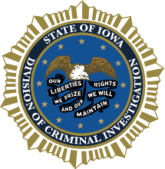
DCI Account Number: ___4437___________
(if applicable)

To: | Iowa Division of Criminal Investigation |  | From: | Iowa Campus Compact
 | Support Operations Bureau, 1st Floor |  |  | 2500 Fleur Drive
 | 215 E. 7th Street
 | Des Moines, Iowa 50319 |  |  | Des Moines, IA 50321
 | (515) 725-6066
 | (515) 725-6080 Fax |  |  | 515 235 4681
 |  |  | Phone:
 |  |  | Fax:

I am requesting an Iowa Criminal History Record Check on:
Last Name (mandatory) | First Name (mandatory) | Middle Name (recommended)
Date of Birth (mandatory) | Gender (mandatory) | Social Security Number (recommended)
 | □Male □Female
Waiver Information: Without a signed waiver from the subject of the request, a complete criminal history record may not be releasable, per Code of Iowa, Chapter 692.2. For complete criminal history record information, as allowed by law, always obtain a waiver signature from the subject of the request.
Waiver Release: I hereby give permission for the above requesting official to conduct an Iowa criminal history record check with the Division of Criminal Investigation (DCI). Any criminal history data concerning me that is maintained by the DCI may be released as allowed by law.

Waiver Signature: _______________________________________________________________________ Date ___________

Iowa Criminal History Record Check Results |  | (DCI use only)
As of ___________________, a search of the provided name and date of birth revealed:
 | □ No Iowa Criminal History Record found with DCI
 | □ Iowa Criminal History Record attached, DCI #______________
DCI initials______________

DCI-77 (Approved 08/25/10; updated 05/31/13; reviewed 08/13/14)

Waiver Information:

Iowa law does not require a waiver. However, without a signed waiver from the subject of the request any arrest over 18 months old, without a final disposition, cannot be released to a non-law enforcement agency.

Deferred judgments where DCI has received notice of successful completion of probation also cannot be released to non-law enforcement agencies without a signed waiver from the subject of the request.

If the “No Iowa Criminal History Record found with DCI” box is checked, it could mean that the information on file is not releasable per Iowa law without a waiver.

General Information:

The information requested is based on name and exact date of birth only. Without fingerprints, a positive identification cannot be assured. If a person disputes the accuracy of information maintained by the Department, they may challenge the information by writing to the address on the front of this form or personally appearing at DCI headquarters during normal business hours.

The records maintained by the Iowa Department of Public Safety are based upon reports from other criminal justice agencies and therefore, the Department cannot guarantee the completeness of the information provided.

The criminal history record check is of the Iowa Central Repository (DCI) only. The DCI files do not include other states’ records, FBI records, or subjects convicted in federal court within Iowa.

In Iowa, a deferred judgment is not considered a conviction once the defendant has been discharged after successfully completing probation. However, it should be noted that a deferred judgment may still be considered as an offense when considering charges for certain specified multiple offense crimes, i.e. second offense OWI. If a disposition reflects that a deferred judgment was given, you may want to inquire of the individual his or her current status.

A deferred sentence is a conviction. The judge simply withholds implementing a sentence for a certain probationary period. If probation is successful, the sentence is not carried out.

Any questions in reference to Iowa criminal history records can be answered by writing to the address on the front of this form or calling (515) 725-6066 between 8:00 a.m. and 4:00 p.m., Monday - Friday.

REMINDER - (1) Send in a separate Request Form for each last name, (2) a fee is required for each last name submitted, (3) a completed Billing Form must be submitted with all request(s).

Iowa law requires employers to pay the fee for potential employees’ record checks.

Request Form
Page 2

How to complete a fingerprint card
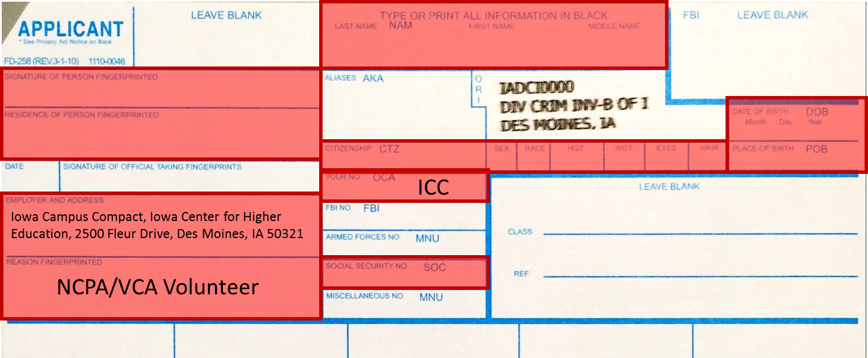
- Complete all of the sections outlined in red.
- The “Employer Address”, “Reason Fingerprinted” and “OCA” sections MUST have the information listed above.
- Complete the remaining sections with your personal information. This information MUST match what is listed on your government issued ID (i.e., Drivers License)
- Submit your completed fingerprint card to your ICAP supervisor
- Any cost you incur in order to have your fingerprints taken MUST be reimbursed by Iowa Campus Compact or your host site.
- You will need your Government Issued ID (i.e. Drivers License) when you get your fingerprints taken.

Don’t forget to submit a copy of your government issued ID!

Iowa Department of Public Safety
Division of Criminal Investigation
Waiver Agreement and Statement
For National Criminal History Record Checks
as authorized by state legislation or federal statute
Pursuant to the Iowa User Agreement, this form must be completed and signed by every current or prospective licensee, employee, volunteer, and contractor/vendor, for whom criminal history records are requested by a Qualified Entity (QE) under state legislation or federal statute.
I hearby authorize (Name of QE) |  |  | Iowa Campus Compact
to submit a set of my fingerprints to the Iowa Department of Public Safety (DPS), Division of Criminal Investigation (DCI) for the purpose of accessing and reviewing Iowa and FBI national criminal history records that may pertain to me. By signing this Waiver Agreement, it is my intent to authorize the dissemination of any Iowa and/or national criminal history record that may pertain to me to the QE with which I am or am seeking to be licensed, employed or to serve as a volunteer. Furthermore, I authorize the QE to forward this agreement to DCI upon request.
I understand that, until the criminal history record check is complete, the QE may choose to deny me unsupervised access to children, elderly or individuals with disabilities. I further understand that, if applicable, the QE may choose to deny my application or grant me a limited or restricted license until the criminal history record check is complete.
I understand that I am entitled to challenge the accuracy and completeness of any information contained in the criminal history report, if any, received on me. I understand that the procedures for obtaining a change, correction, or updating of my criminal history record are set forth at Title 28, Code of Federal Regulations (CFR), Section 16.34. I may obtain a prompt determination as to the validity of my challenge before a final decision is made about my status as a licensee, employee, volunteer, contractor or subcontractor.
- I have been convicted of a crime |  |  |  | - I have not been convicted of a crime
If convicted, describe the crime(s) and the particulars of the conviction(s) in the space below. Use additional paper as needed:
I am a current or prospective (check one): |  |  |  | - Licensee |  |  | - Employee | - Volunteer |  |  | - Contractor/Vendor
Please complete the following information as it appears on valid photo identification:
Printed Name:
Address:
Date of Birth:
Signature: |  |  |  |  |  |  |  |  | Date:
TO BE COMPLETED BY THE QAULIFIED ENTITY:
QE Name: |  | Iowa Campus Compact |  |  |  |  |  |  |  | OCA: |  | ICC
Address: |  | Iowa Center for Higher Education 2500 Fleur Drive, Des Moines, IA 50321
Telephone: |  | 515-235-4681 |  |  | Fax:
This waiver must be retained at the QE for one year after the applicant is no longer relevant to the QE or one year post audit by DCI, whichever is longer. Do not send to DCI unless requested.

DCI-45 (07/15/15)
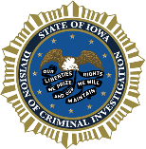 |  |  | Iowa Department of Public Safety  Division of Criminal Investigation

NONCRIMINAL JUSTICE APPLICANT'S RIGHTS
As an applicant who is the subject of a national fingerprint-based criminal history record check for a noncriminal justice purpose (such as licensing, employment, or adoption), you have certain rights which are discussed below:
- You must be provided written notification that your fingerprints will be used to check the criminal history record of the FBI.
- If you have a criminal history record, the officials making a determination of your suitability for the job, license, or other benefit must provide you the opportunity to complete or challenge the accuracy of the information in the record.
- The officials must advise you that the procedures for obtaining a change, correction, or updating of your criminal history record are set forth at Title 28, Code of Federal Regulations (CFR), Section 16.34.
- If you have a criminal history record, you should be afforded a reasonable amount of time to correct or complete the record (or decline to do so) before the officials deny you the job, license, or other benefit based on information in the criminal history record.
You have the right to expect that officials receiving the results of the criminal history record check will use it only for authorized purposes and will not retain or disseminate it in violation of federal statute, regulation or executive order, or rule, procedure or standard established by the National Crime Prevention and Privacy Compact Council.
If agency policy permits, the officials may provide you with a copy of your FBI criminal history record for review and possible challenge. If agency policy does not permit it to provide you a copy of the record, you may obtain a copy of the record by submitting fingerprints and a fee to the FBI. Information regarding this process may be obtained at http://www.fbi.gov/about-us/cjis/background-checks.
If you decide to challenge the accuracy or completeness of your FBI criminal history record, you should send your challenge to the agency that contributed the questioned information to the FBI. Alternatively, you may send your challenge directly to the FBI. The FBI will then forward your challenge to the agency that contributed the questioned information and request the agency to verify or correct the challenged entry. Upon receipt of an official communication from that agency, the FBI will make any necessary changes/corrections to your record in accordance with the information supplied by that agency. (See 28 CFR 16.30 through 16.34.)

Iowa Department of Public Safety
Division of Criminal Investigation

 |  |  |  |  |  |  | Preferred Method of Contact
 | Member Name
 | Phone
 | Email
 | Address
 | City |  | State |  | Zip

I would like to receive text message reminders and notifications from Iowa Campus Compact.
Iowa Campus Compact uses an online text messaging system called Remind to send notifications. You will only receive text messages for the duration that you are in the program. You will only receive text messages about program deadlines and events specific to your service in the Iowa College AmeriCorps Program.

EMERGENCY CONTACT INFORMATION
 | Emergency Contact Name |  | Preferred Method of Contact
 | Relationship to Contact
 | Emergency Contact Home Phone
 | Emergency Contact Work Phone
 | Emergency Contact Cell Phone
 | Emergency Contact Email

